NASCO FEEDING MINDS

PROVIDING DIGITAL LITERACY TRAINING

IN GHANA

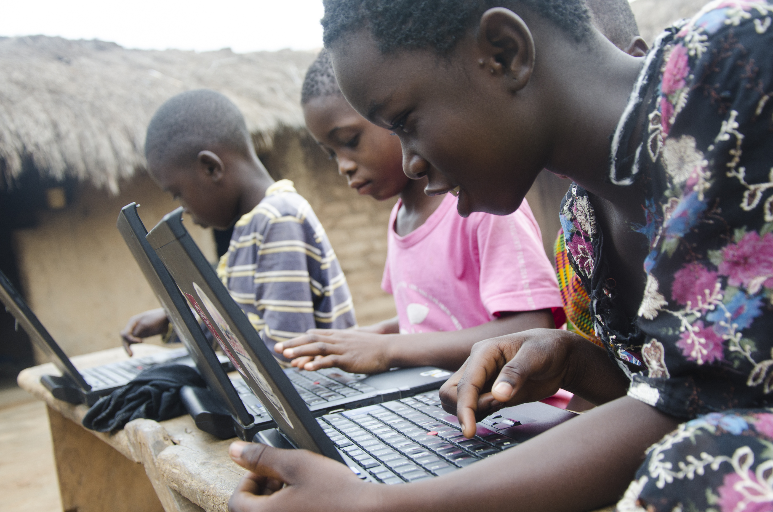*Beneficiaries of NASCO Foundation. Photo credit: Nasco ICT*

# Executive Summary

Founded in 2012, Nasco ICT has launched a series of projects in Ghana aimed at providing children and young people with the necessary computer tools and skills needed to access education through information and communications technologies (ICTs). The project installs computer centers in local schools and provides training classes for students and community members on computer basics and more advanced topics like web development. The objective is to set up ICT laboratories and promote technology literacy for students in the northern part of Ghana and other underserved communities. Where it is not possible for the government to provide the necessary infrastructure, their goal is to close the gap for rural communities and provide ICT literacy.

*Keywords: digital literacy, education, rural, Ghana*

# Context

Ghana was the first country in Africa to be connected to the Internet. Today, telecommunications is the main economic sector of Ghana. To support the digitization of the economy, the government is embarking on a digital inclusion agenda with a goal of capturing and benefiting all citizens. They also plan to provide affordable broadband services to all Ghanaians by 2020. According to a 2012 study by Research ICT Africa, 60 percent of the respondents answered that the high cost of access prevented them from using the Internet. Broadband services were found to be very expensive for most Ghanaians.

ICT has long been an emphasis in the educational development plans of the Ministry of Education. Ghana’s ICT for Accelerated Development (ICT4AD) policy issued in 2003 has enabled a number of ICT projects and initiatives facilitated by partnership between the public and private sectors. Currently, the National Communication Authority has embraced TV White Space technology to extend Internet services to rural areas, hoping to improve teaching and learning of ICT in schools.

Civil society in Ghana also plays a role in promoting ICT in education. An example is the partnership between KEY for Life and Young at Heart Ghana that aims to equip children and young adults to learn better using computers. Another example is Africa ICT Right, a nonprofit organization with various projects related to equipping teachers with necessary skills to integrate ICTs into their lessons, establishing computer centers in underserved communities, and distributing low-cost refurbished computers with open-source educational software.

|  |  |  |  |
| --- | --- | --- | --- |
| **Ghana** | | | |
| **Population**  **(UN, 2015)** | 26,984,328 | **Fixed broadband subscriptions (%)**  **(ITU, 2016)** | 0.31 |
| **Population density**  **(people per sq.km)**  **(UN, 2015)** | 113.13 | **Mobile cellular subscriptions (%)**  **(ITU, 2016)** | 139.13 |
| **Median household income**  **(Gallup, 2006-2012)** | US$ 2050 | **Individuals using the Internet (%)**  **(ITU, 2016)** | 34.7 |
| **Education**  **(Mean years of schooling)**  **(UNDP, 2013)** | Male: 8.1  Female: 5.9 | **Individuals using the Internet by gender (%)**  **(ITU, 2016)** | N/A |

# Project Description

The NASCO Foundation seeks to bridge the gap between the industrialized world and Sub-Saharan Africa through information sharing and training. It provides academic courses to support educational initiatives to improve the lives of underprivileged communities in the Republic of Ghana.

NASCO’s courses are built according to the Ghana Education Services curriculum, but they also have additional courses in web application and website development. They offer evening classes and alternate schedules to accommodate their users who are between the ages of 10 and 18. Another project for secondary schools covers users up to age 22.

There are three extant training centers, each of which is equipped with between 30 and 40 computers with five computers on standby for quick replacement. Two new centers will have roughly the same – approximately 35 computers. Four out of the five centers are located in schools, while the remaining one is in a publically accessible community library. Only the library is Internet equipped at present, however.

Nasco ICT purchased the technology for the pilot center, but all remaining computers are donated or sponsored, mostly by Nibus, a Danish civil society group. The Spanish branch of Nasco ICT sponsored them with funding for 75 computers. The space is free, so the only cost is for the first computers and ongoing pay for teachers. Nasco ICT sponsors two teachers, while others are already teachers with the government organization Ghana Education Service and they teach in the center with Nasco ICT-provided training (where there is one teacher per center). Students pay US$ 3 per term for services (three terms per year).

|  |  |  |  |
| --- | --- | --- | --- |
| Project details | | | |
| Technology | Computers | **Training** | Teacher training |
| Year program started | 2012 | **Cost to users** | US$ 3 per year |
| Geography | Rural | **Total cost of program** | Fixed cost: US$ 4,235 per center  Operational cost: US$ 2,200 |
| User profile | 12,200 students,  10-22 years old | **Associated organizations** | Africa Yes,  Ghana Education Service,  Labdoo,  NASCO ICT Spain,  Nibus (Denmark),  Red Bull |

# Progress and Results

Three ICT Centers have served approximately 12,200 students since 2012. Since September 2014, the northern Ghanaian town of Sawla has a library with computers accessed by more than 2,200 students from eight different educational centers. The center offers free introduction to computer science classes where users learn computer basics, both the operating system and Microsoft Office suite of programs. The creation of the center was possible thanks to donations and support from Nibus, Africa Yes, Red Bull, and Labdoo. Four schools in St. Augustine use the computer classroom to train more than 1,300 students in an area with serious obstacles to accessing training of this type.

A 2016 assessment of student learning with the Nasco ICT system reports an increase in test scores from 52 percent to 71 percent proficiency in integrated science (of which ICT is a subfield).The University of Tuna, located in the north of the country, has a computer center in its institute where almost 2,000 students enjoy the possibility of learning to use a personal computer (PC). The center is not only open to students, but teachers, school employees, and the public. The creation of the center was possible due to support from Nibus. Two new centers launched this year and are not included.

# Challenges

**Lack of access to devices –** There are not enough computers for the number of students, so they do not have individual access, which limits learning. Often there are two or more students per computer. Students have no prior knowledge of ICTs, and it has no continuity with their home lives. Thus, they want to be able to offer students more time more consistently for a faster pace of learning.

**Limited and irregular electricity access –** Electricity is already present but it is expensive. Only one center has Internet as a pilot project, and while the rest of them may also get electrified.

**Lack of affordable access –** Internet data is currently prohibitively expensive.

**Community resistance –** Parents associate negative social practices with Internet access, so it is a cultural shift for them to allow their children to use the new technology.

# Nasco ICT’s Suggestions for Future Projects

**Local support is key to project implementation –** The project team highlighted how gaining support, especially from the students’ parents, in advance of implementation was very helpful. Getting financial support has been extremely difficult, so NASCO ICT tries to get parents to commit to giving them a venue to set up, pay the money per term, and pay the teacher.

**Alternate funding streams are necessary for sustainability –** There is a need for alternate funding streams within the organization. For instance, a second Nasco project involves bee keeping as a source of revenue for the organization’s ICT program.

# Sources

Seidu, B.N. (2017, September 20) Personal Interview.

Project website: <http://www.nascoict.org/>